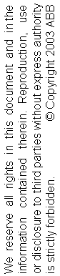
Transplant Slave IP for Current Controller Description

Edition | Date | Issued by | Comments
0.1 | 2009-09-23 | CNCRC/ Ye-Ye Zhang | Proposal

TABLE OF CONTENTS

1. INTRODUCTION 3
2. OVERVIEW 4
3. detailed description 6
3.1 Emergency Stop 6
3.2 Axis Select 7
3.3 Gear Assembly 8
3.4 Casting Assembly 10
3.5 Calibration 12
3.6 Test Result Indication 15
4. protocols and editions 16
4.1 Edition 0.1 16

INTRODUCTION
This document contains the transplant description of the Current Controller Slave IP core from original Firmware C19.

The IP core shall be used in the Current Controller FPGA and it shall be connected with an embedded CPU through a FSL bus.

This document only describes the essential transplantation of the Firmware C19. The firmware should inherit most of the C19 functions. The functions described in this document should be limited to changing parts during the transplantation. It is strongly recommended to understand the mechanism of Firmware C19 before reading this document.

OVERVIEW

This document describes the transplantation from FW C19 to IP core for slave MicroBlaze in Current Controller for Gear Assembly production. This IP core remains most of the function in FW C19. And the cut line for transplant is decided to be set between the EtherCAT and the 16-bit uController.

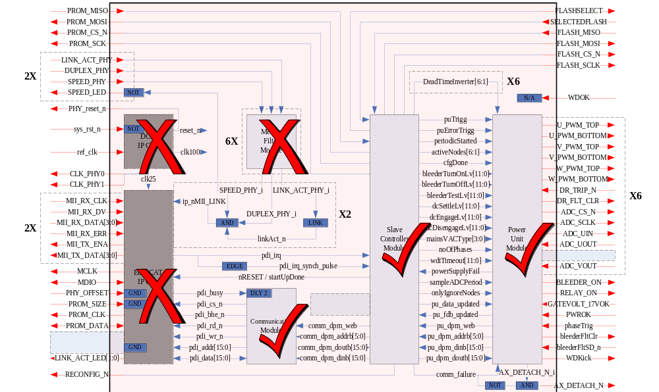
Fig 1 Implemented Parts of the FPGA C19

The FW C19 transplantation is designed for the whole logic parts of FW C19, which is implemented in Fig 1. It is based on the FW C19 IP Core without EtherCAT (etc). Here, 16-bit uController is replaced by FSL Adapter; mailbox mechanism is replaced by SDO Adapter, as shown in Fig 2.

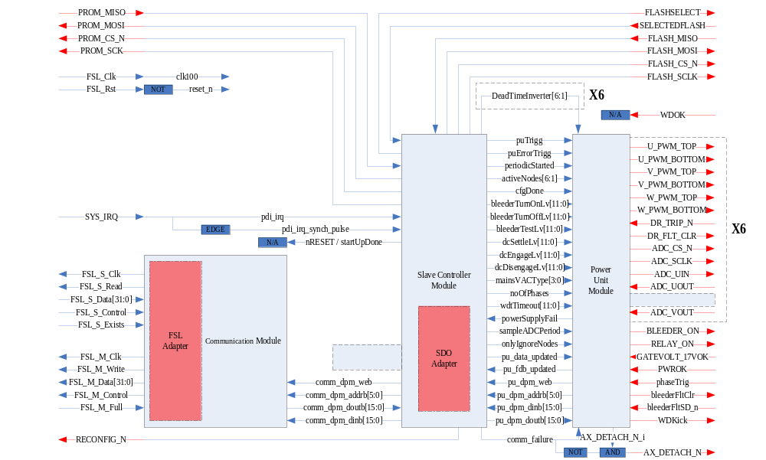

Fig 2 Architecture of the FPGA C19 Transplantation

Note that FSL_Rst signal is inverted to reset_n in this IP core.

Interrupt signal Irq is generated by other IP core and controlled by CPU. The Irq needs to be edge trigged as only one tick signal pulse for SC event trigger.

detailed description

Main State Machine
The main state machine in this firmware follows the original ESM (EtherCAT State Machine). It fulfils the protocol with Current Controller Microblaze as follow.

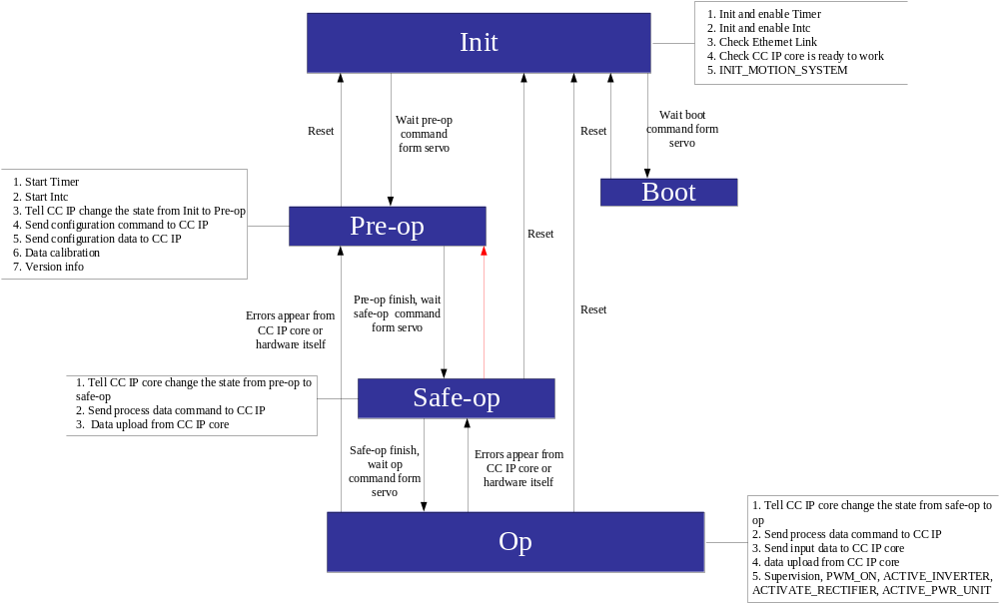
Init
1
.
Init and enable Timer
2
.
Init and enable Intc
3
.
Check Ethernet Link
4
.
Check CC IP core is ready to work
5
.
INIT
_
MOTION
_
SYSTEM
Pre
-
op
Boot
Safe
-
op
Op
1
.
Start Timer
2
.
Start Intc
3
.
Tell CC IP change the state from Init to Pre
-
op
4
.
Send configuration command to CC IP
5
.
Send configuration data to CC IP
6
.
Data calibration
7
.
Version info
1
.
Tell CC IP core change the state from pre
-
op to
safe
-
op
2
.
Send process data command to CC IP
3
.
Data upload from CC IP core
1
.
Tell CC IP core change the state from safe
-
op to
op
2
.
Send process data command to CC IP
3
.
Send input data to CC IP core
4
.
data upload from CC IP core
5
.
Supervision
,
PWM
_
ON
,
ACTIVE
_
INVERTER
,
ACTIVATE
_
RECTIFIER
,
ACTIVE
_
PWR
_
UNIT
Wait pre
-
op
command
form servo
Reset
Wait boot
command form
servo
Reset
Pre
-
op finish
,
wait
safe
-
op command
form servo
Reset
Safe
-
op finish
,
wait op
command form
servo
Errors appear from
CC IP core or
hardware itself
Reset
Errors appear from
CC IP core or
hardware itself
Fig 3 Main State Machine

State | Description
Init | Startup
Bootstrap | Reset
PreOP | Configuration
SafeOP | Process data input to CPU
OP | Process data input and output

State Transition | Description
To_Init | Set to startup (available from each state to Init state)
Bootstrap_Init | Restart from boot
Init_Bootstrap | Set to be ready for restart
Init_PreOP | Start configuration
PreOP_SafeOP | Start process data input
SafeOP_OP | Start process data output
OP_SafeOP | Stop process data output
SafeOP_PreOP | Stop process data input
OP_PreOP | Stop process data input and output

Slave Controller State Machine

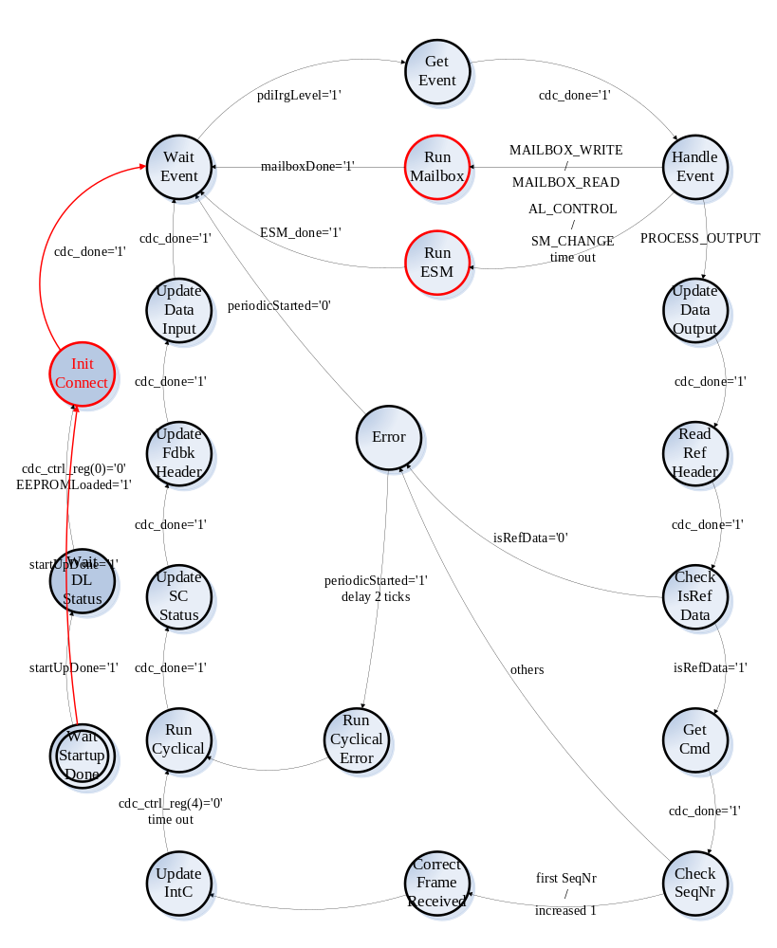
Fig 4 Slave Controller State Machine

InitConnect | Addr | Value
FW_Revision | 0x1004 | 0x0035
PU_DSQC | 0x1006 | 0x0299
PU_Version | 0x1008 | 0x0001
PU_Revision | 0x100A | 0x0001

AL Event Request Mask | Addr
AL_Event_Request_addr | 0x0220

AL Event Request Mask | Value
AL_CONTROL_EVENT | 0x0001
SM_CHANGE_EVENT | 0x0010
MAILBOX_WRITE_EVENT | 0x0100
MAILBOX_READ_EVENT | 0x0200
PROCESS_OUTPUT_EVENT | 0x0400

FILE_LOCATION_ADDR | Addr
ECS_Process_Data_Output_Start_Addr | 0x1100
ECS_Process_Data_Input_Start_Addr | 0x1300

Ref Header | Value
(7 DOWNTO 0) driveUnitType | in drive unit header for use with wireshark
(11 DOWNTO 8) RefSeq | increased by 1 since last frame
(15) isReferenceData | 1

Unit Cmd | Value
(0) resetCommFailure | 0; 1 for reset
(2) sampleADCEveryPeriod | 0 / 1

Legacy ESM State Machine

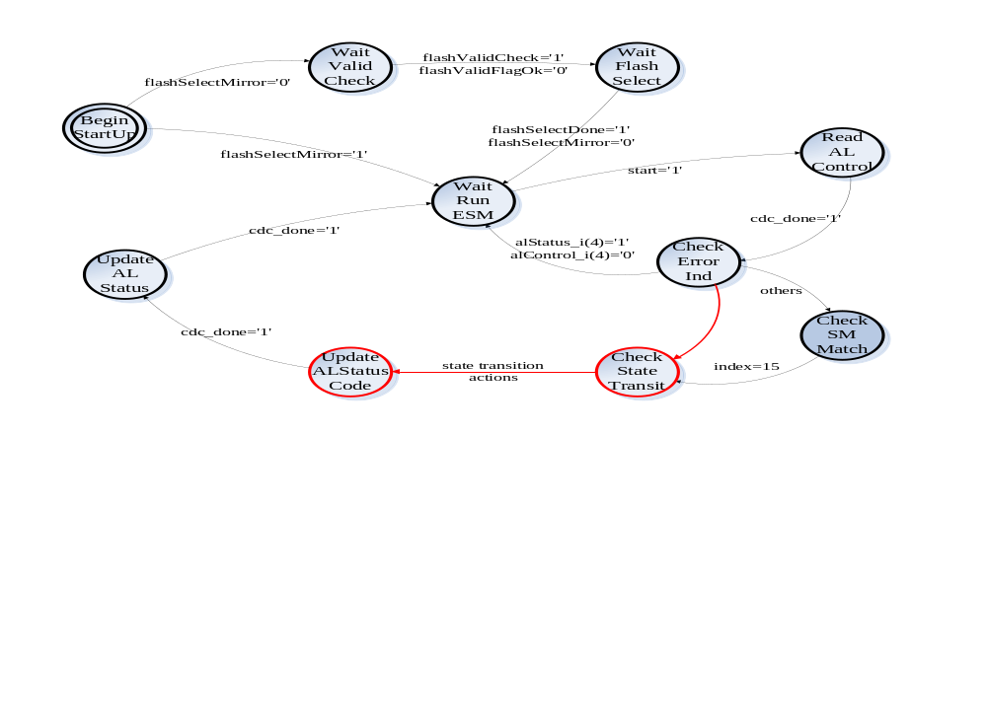
Fig 5 State Machine of Legacy ESM

AL Event Request Mask | Addr
AL_CONTROL_ADDR | 0x0120
AL_STATUS_CODE_ADDR | 0x0134
AL_STATUS_ADDR | 0x0130

I think there is a need for a button: Accept and a button: Restart so that the system knows the assembly is successful.
AL Control / Status State | Value
alStatus(4) | 1
INIT_STATE | 0x1
BOOTSTRAP_STATE | 0x3
PRE_OP_STATE | 0x2
SAFE_OP_STATE | 0x4
OP_STATE | 0x8

AL Status Code | Value
No error | 0x0000
Unspecified error | 0x0001
Unknown requested state change | 0x0011
Unknown requested state | 0x0012
Invalid mailbox configuration | 0x0015
Invalid mailbox configuration | 0x0016
Invalid syncmanager configuration | 0x0017

SDO Adapter

The mailbox will be replaced as follow. This block’s function is to copy data between the FSL Bus and the SDO process. This state machine architecture is referenced to the cyclical block.
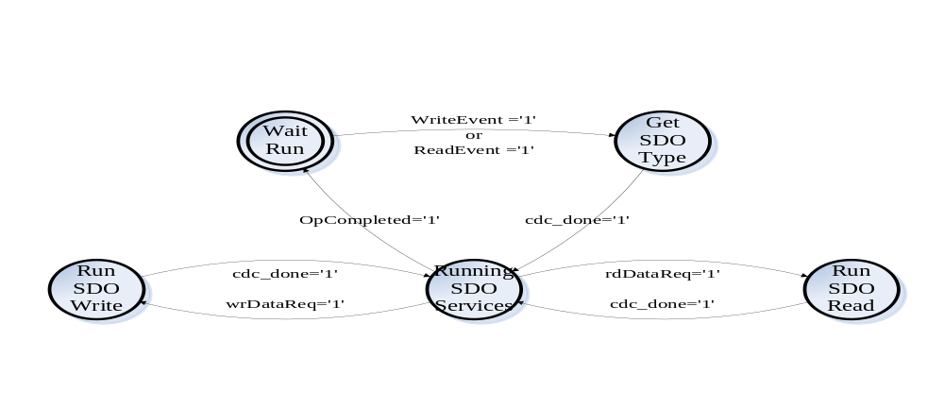
Fig 6 State Machine of SDO Interface

FILE_LOCATION_ADDR | Addr
FILE_LOCATION_ADDR | 0x0770

FILE_LOCATION | Value
RESERVED_LOCATION | 0x0
FPGA_FW_INFO_MEM | 0x1
EEPROM_MEM | 0x2
FLASH_MEM | 0x4
FPGA_APPLIC_CONF_DATA_MEM | 0x5

The configuration data during config sequence of the startup is listed below.

Size in bits | Word addr | Field | Description
4 | 0x00 | MaxLostFrames | Maximum Number of Lost/ignored  consecutive reference messages.
8 | 0x01 | MDUProtocolVersion | Process data protocol version for MDU:s
12 | 0x02 | ADC_BleederTurnOnLevel | Rectifier Config. A/D converter value for turn on level for the bleeder.
12 | 0x03 | ADC_BleederTurnOffLevel | Rectifier Config. A/D converter value for turn off level for the bleeder.
12 | 0x04 | ADC_BleederTestLevel | Rectifier Config. A/D converter value representing the DC level that the DC link shall drop to when engaging the bleeder during startup test
12 | 0x05 | ADC_DCSettleLevel | Rectifier Config. A/D converter value representing that DC is stable when its ripple is less than this value
12 | 0x06 | ADC_DCEngageLevel | Rectifier Config. A/D converter value for engage the relays, i.e. switching inrush circuit to running mode
12 | 0x07 | ADC_DCDisengageLevel | Rectifier Config. A/D converter value for disengage the relays, i.e. switching inrush circuit to charging mode
4 | 0x08 | RectifierConfigValid | Mains AC Type:  0 – Not Configured  1 – Configured  2 – 15 Reserved
1 | 0x09 | OnePhaseMains | 0 – Three Phases  1 – One Phase
12 | 0x0A | DeadtimeInverter1 | Deadtime in 10 ns resolution
12 | 0x0B | DeadtimeInverter2 | Deadtime in 10 ns resolution
12 | 0x0C | DeadtimeInverter3 | Deadtime in 10 ns resolution
12 | 0x0D | DeadtimeInverter4 | Deadtime in 10 ns resolution
12 | 0x0E | DeadtimeInverter5 | Deadtime in 10 ns resolution
12 | 0x0F | DeadtimeInverter6 | Deadtime in 10 ns resolution
16 | 0x10 | WatchdogTimeout | 10 ns resolution-value to use as timeout when no data is received by the Slave. The supervision should be enabled when the first package arrive after entering OP state.
16 | 0x11 | WatchdogTimeoutInterval | 10 ns resolution-value to use as timeout for next package when a package is lost.

Hardcode values in MDU firmware

Size in bits | Field | Description
8 | FW version
8 | FW revision
8 | Latest MDU RoboCAT version supported
14 | PWM delay time min value | Number of 10 ns ticks
14 | PWM delay time max value | Number of 10 ns ticks

Cyclical State Machine
Process data area for outputs

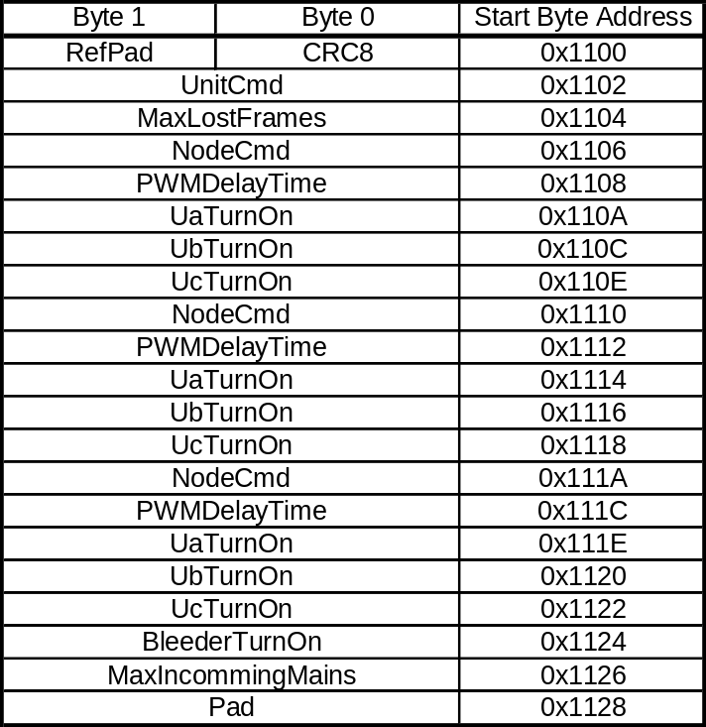

Process data area for inputs

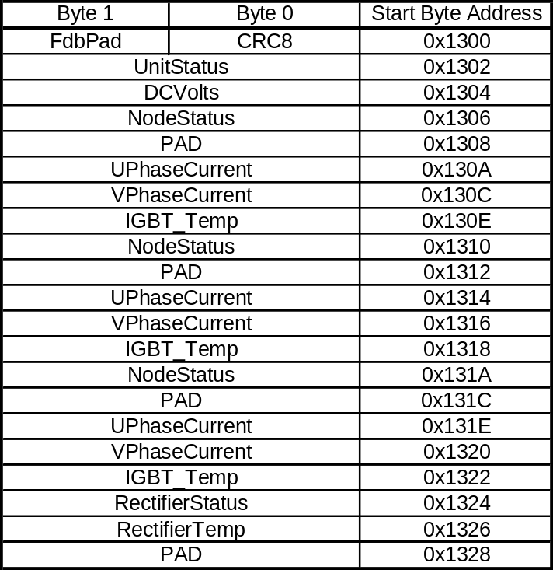

FSL Adapter

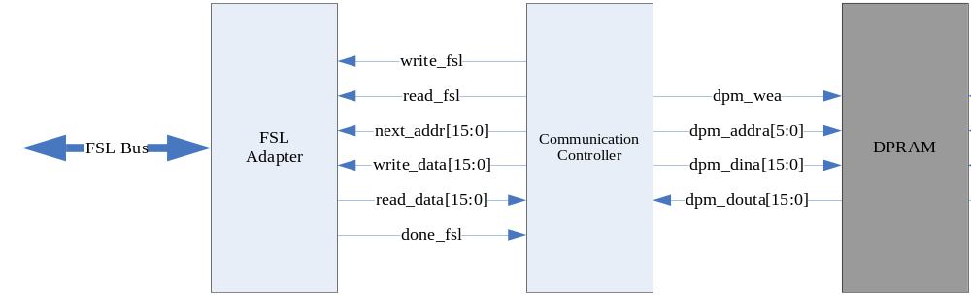Fig 7 Structure of Communication Module

FSL Bus width is 32 bit. The high 16 bit indicates the legacy address (_addr[15:0]); and the low 16 bit indicates the data. When receive the FSL 32 bit data, FSL Adapter automatically check the legacy address, which should accords to input address (_addr[15:0]). Otherwise, the data will be dropped with warning. No Register Array or DPM exists in FSL Adapter. The transfer data will be blocked in the buffer of FSL Bus. After one operation cycle is done, the FSL Adapter sends a done_fsl signal pulse.

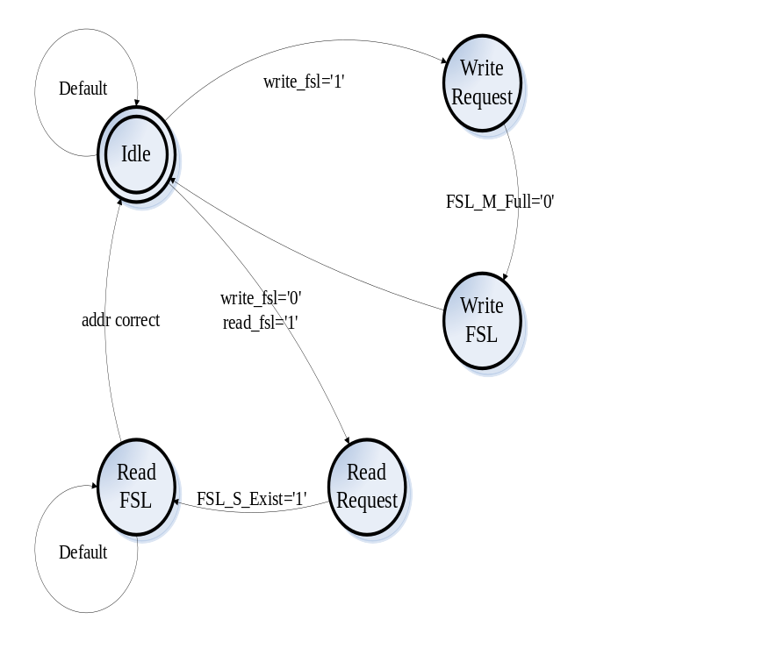
Fig 8 State Machine of FSL Adapter

Memory Map

Table 1 shows the memory map in EtherCAT State Machine, it includes the control/status registers and input/output data.

Table 1 Memory Map in Current Control IP Core
Type | Name | ESM  (8bit) | Comm DPM | SC DPM | Value
 | Physical Start Address | 0x0000
 | Length | 0x0002
 | Control Register | 0x0004
 | Status Register | 0x0005
 | Activate | 0x0006
 | PDI Control | 0x0007
 | DL_Status | 0x0110 |  |  | 0x0000  0x0001
 | AL_Control | 0x0120
 | AL_Status | 0x0130 |  |  | 0x0001
 | AL_Status_Code | 0x0134 |  |  | 0x0000
 | AL_Event_Mask | 0x0204 |  |  | 0x0000  0x0701  or  0x0101
 |  | 0x0206 |  |  | 0x0000  0x0000
 | AL_Event_Request | 0x0220
 | Watchdog_Status_Process_Data | 0x0440
 | SyncManager[0] | 0x0800 – 0x0807 0x0806 |  |  | 0x0100
 | SyncManager[1] | 0x0808 – 0x080F 0x080E |  |  | 0x0100
 | SyncManager[2] | 0x0810 – 0x0817 0x0816 |  |  | 0x0100
 | SyncManager[3] | 0x0818 – 0x081F 0x081E |  |  | 0x0100
 |  | 0x0826 |  |  | 0x0100
 |  | 0x082E |  |  | 0x0100
 |  | 0x0836 |  |  | 0x0100
 |  | 0x083E |  |  | 0x0100
 |  | 0x0846 |  |  | 0x0100
 |  | 0x084E |  |  | 0x0100
 |  | 0x0856 |  |  | 0x0100
 |  | 0x085E |  |  | 0x0100
 |  | 0x0866 |  |  | 0x0100
 |  | 0x086E |  |  | 0x0100
 |  | 0x0876 |  |  | 0x0100
 |  | 0x087E |  |  | 0x0100
 | FW_revision | 0x1004 |  |  | 0x0035
 | PU_DSQC | 0x1006 |  |  | 0x0299
 | PU_Version | 0x1008 |  |  | 0x0001
 | PU_Revision | 0x100A |  |  | 0x0001
 | PWM_CTRL |  |  | B111111
 | PWM_CFG |  |  | B111101
 | CTRL_REG |  | 0x0000
 | Status_reg |  | 0x0001
 | Config_reg |  | 0x0002
 | DATA_REG |  | 0x0003
 | ADDR_REG |  | 0x0004
 | RefPad & CRC8 (RefHeader) | 0x1100 | 0x0005
 | UnitCmd | 0x1102 | 0x0006 | 0x0000
 | MaxLostFrames | 0x1104 | 0x0007
 | NodeCmd | 0x1106 | 0x0008 | 0x0001
 | PWMDelayTime | 0x1108 | 0x0009
 | UaTurnOn | 0x110A | 0x000A | 0x0002
 | UbTurnOn | 0x110C | 0x000B | 0x0003
 | UcTurnOn | 0x110E | 0x000C | B000110
 | NodeCmd | 0x1110 | 0x000D | B000111
 | PWMDelayTime | 0x1112 | 0x000E | B001000
 | UaTurnOn | 0x1114 | 0x000F | B001001
 | UbTurnOn | 0x1116 | 0x0010 | B001010
 | UcTurnOn | 0x1118 | 0x0011 | B001011
 | NodeCmd | 0x111A | 0x0012 | B001100
 | PWMDelayTime | 0x111C | 0x0013 | B001101
 | UaTurnOn | 0x111E | 0x0014 | B001110
 | UbTurnOn | 0x1120 | 0x0015 | B001111
 | UcTurnOn | 0x1122 | 0x0016 | B010000
 | RECT_REF_PAD1 |  |  | B010001
 | RECT_REF_PAD2 |  |  | B010010
 | BleederTurnOn | 0x1124 | 0x0017
 | MaxIncommingMains | 0x1126 | 0x0018
 | Pad | 0x1128 | 0x0019
input data | FdbPad & CRC8 (FdbkHeader) | 0x1300 | 0x001B  0x0018
input data | UnitStatus | 0x1302 | 0x001C  0x0019
input data | DCVolts | 0x1304 | 0x001D | 0x0020
input data | NodeStatus | 0x1306 | 0x001E | 0x0021
input data | PAD | 0x1308 | 0x001F | B100010
input data | UPhaseCurrent | 0x130A | 0x0020 | B100011
input data | VPhaseCurrent | 0x130C | 0x0021 | B100100
input data | IGBT Temp | 0x130E | 0x0022 | B100101
input data | NodeStatus | 0x1310 | 0x0023 | B100110
input data | PAD | 0x1312 | 0x0024 | B100111
input data | UPhaseCurrent | 0x1314 | 0x0025 | B101000
input data | VPhaseCurrent | 0x1316 | 0x0026 | B101001
input data | IGBT Temp | 0x1318 | 0x0027 | B101010
input data | NodeStatus | 0x131A | 0x0028 | B101011
input data | PAD | 0x131C | 0x0029 | B101100
input data | UPhaseCurrent | 0x131E | 0x002A | B101101
input data | VPhaseCurrent | 0x1320 | 0x002B | B101110
input data | IGBT Temp | 0x1322 | 0x002C | B101111
input data | RectifierStatus | 0x1324 | 0x002D | B110000
input data | RectifierTemp | 0x1326 | 0x002E | B110001
input data | PAD | 0x1328 | 0x002F
input data | MB_WRITE_BUFF_START | 0x1600
input data | MB_READ_BUFF_START | 0x1750
input data | User RAM | 0x0F80 |  |  | 0x0000

protocols and editions

Edition 0.1

